Monday Tuesday Wednesday Thursday Friday
Breakfast  Choice of:  Bagel w/ cream cheese or  Muffin, banana nut or  Cinnamon swirl or  Peanut butter and jelly s/w or  Cereal and or cheese stick  Fruit / Juice / Milk | Breakfast  Choice of:  Bagel w/ cream cheese or  Muffin, banana nut or  Cinnamon swirl or  Peanut butter and jelly s/w or  Cereal and or cheese stick  Fruit / Juice / Milk | Breakfast  Choice of:  Bagel w/ cream cheese or  Muffin, banana nut or  Cinnamon swirl or  Peanut butter and jelly s/w or  Cereal and or cheese stick  Fruit / Juice / Milk | Breakfast  Choice of:  Bagel w/ cream cheese or  Muffin, banana nut or  Cinnamon swirl or  Peanut butter and jelly s/w or  Cereal and or cheese stick  Fruit / Juice / Milk | Breakfast  Choice of:  Bagel w/ cream cheese or  Muffin, banana nut or  Cinnamon swirl or  Peanut butter and jelly s/w or  Cereal and or cheese stick  Fruit / Juice / Milk | 
 | 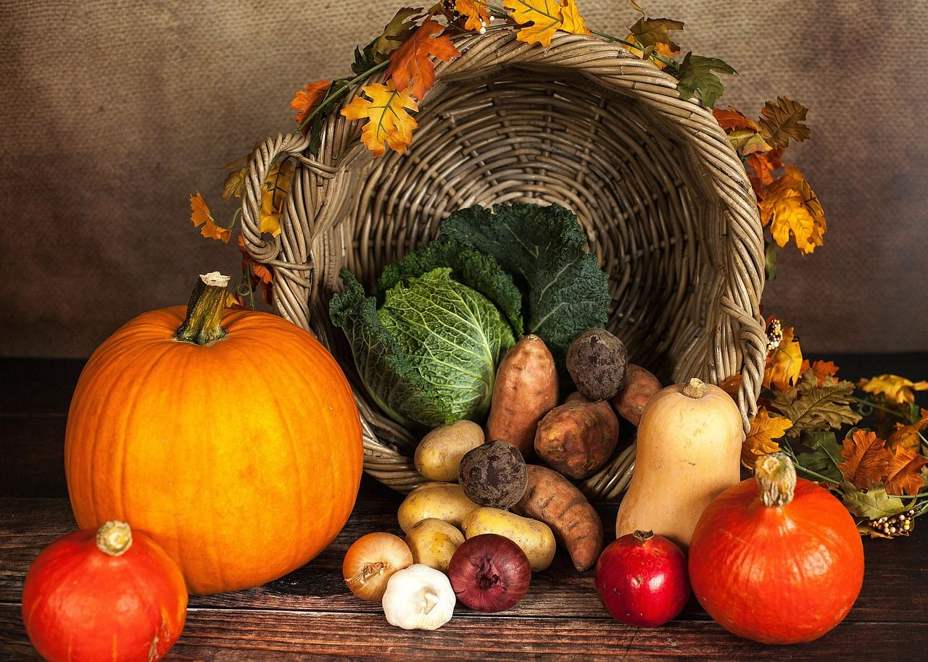 |  |  |  | Breakfast Nutrient AVG  Calories 481  Sodium (mg) 444  Total Fat (g) 6.28  Saturated Fat (g) 2.65  Trans Fat¹ (g) 0.00
02 Lunch  Chicken burger or  Ham and cheese s/w  Baked beans / Potatoes  Fruit / Juice / Milk | 03 Lunch  Chicken tenders w/cookie or Corndog  Potatoes / Veggies  Fruit / Juice / Milk | 04 Lunch  Tacos/rice or  Chicken quesadilla  Beans / Corn  Fruit / Juice / Milk | 05 Lunch  Spaghetti, roll or  Pizza  Broccoli / Carrots  Fruit / Juice / Milk | 06 Lunch  Hotdog or  Cheeseburger  Potatoes/veggies  Fruit / Juice / Milk | Lunch Nutrient AVG  Calories 771  Sodium (mg) 1,145  Total Fat (g) 19.33  Saturated Fat (g) 5.14  Trans Fat¹ (g) 0.00
09 Lunch  Chicken burger or  Ham and cheese s/w  Baked beans / Potatoes  Fruit / Juice / Milk | 10 Lunch  Chicken tenders w/cookie or Corndog  Potatoes / Veggies  Fruit / Juice / Milk | 11  Veterans’ day! | 12 Lunch  Spaghetti, roll or  Pizza  Broccoli / Carrots  Fruit / Juice / Milk | 13 Lunch  Hotdog or  Cheeseburger  Potatoes/veggies  Fruit / Juice / Milk | 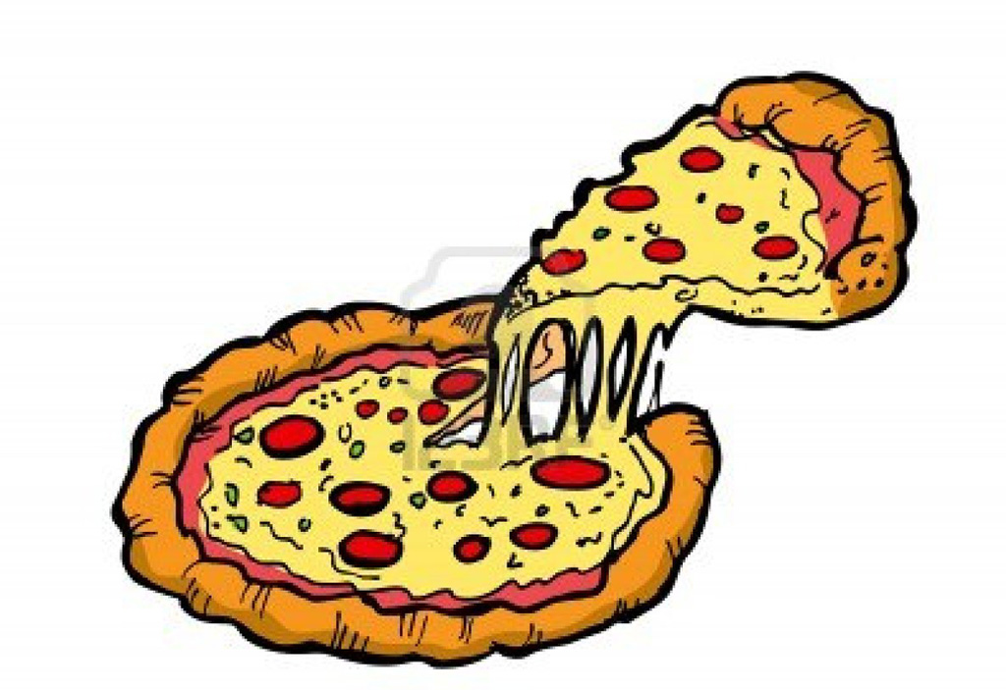
16 Lunch  Chicken burger or  Ham and cheese s/w  Baked beans / Potatoes  Fruit / Juice / Milk | 17 Lunch  Chicken tenders w/cookie or Corndog  Potatoes / Veggies  Fruit / Juice / Milk | 18 Lunch  Tacos/rice or  Chicken quesadilla  Beans / Corn  Fruit / Juice / Milk | 19 Lunch  Spaghetti, roll or  Pizza  Broccoli / Carrots  Fruit / Juice / Milk | 20 Lunch  Hotdog or  Cheeseburger  Potatoes/veggies  Fruit / Juice / Milk | 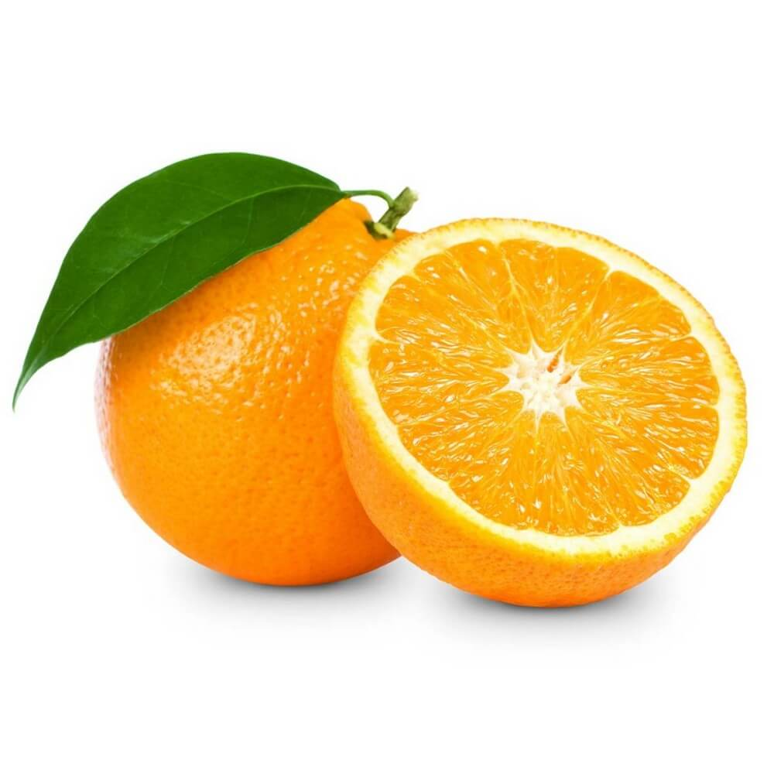
23 Lunch  Chicken burger or  Ham and cheese s/w  Baked beans / Potatoes  Fruit / Juice / Milk | 24 Lunch  Roasted turkey-mashed potatoes w. gravy  Mixed veg. / sugar cookie  Fruit / Juice / Milk | 25 Lunch  Tacos/rice or  Chicken quesadilla  Beans / Corn  Fruit / Juice / Milk | 26  No School! | 27  No School! | 
Assorted fruit, juice, fat-free chocolate and 1% white milk available for breakfast and lunch / Menu items subject to change due to availability.
USDA is an equal opportunity provider.

